Project Title: Smart Lender - Applicant Credibility Prediction for Loan Approval Project Design Phase-I Team ID : PNT2022TMID36001

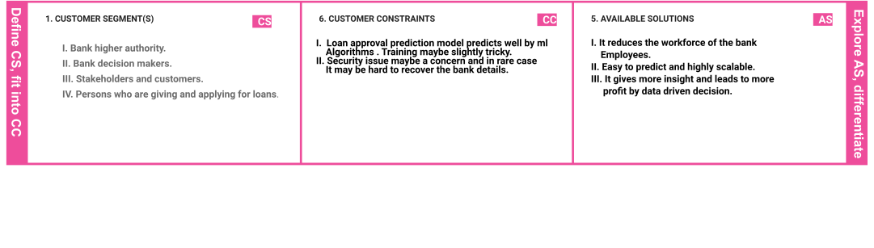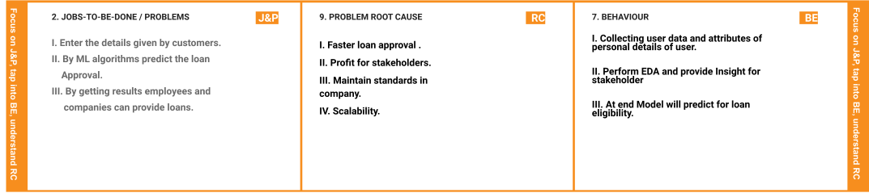

|  |  |  |  |  |  |  |
| --- | --- | --- | --- | --- | --- | --- |
|  | **3. TRIGGERS** | **TR** | **10. YOUR SOLUTION**   1. **Providing cleaner visuals to stakeholders.** 2. **Helping higher level and employees to take data driven decision.** 3. **Accurate ML model to predict customer data** 4. **Highly scalable - Transfer learning allows high**   **scalability and can be used across different level and locations of particular bank or ﬁnance company.** | **SL** | 1. **CHANNELS of BEHAVIOUR**   **CH**   * 1. **ONLINE**   **Online loan approval system – Customers know loan eligibility through online service**   * 1. **OFFLINE**   **Bank and finance – Employees work offline easily with least effort** |  |
| **I. Scope of ML and data science increases** |  |
| **day by day.** |  |
| **II. Financial and Banks are in need of faster** |  |
| **loan approval model.** |  |
| **4. EMOTIONS : BEFORE / AFTER EM** | |
| **Before : Manual workload to check for loan eligibility** | |
| **After : Rapid approval in predicting the loans** | |